EX:No.4 STATIONARITY CHECK 221501027 04/03/25

AIM : To implement stationarity check using Augmented Dickey Fuller test and Visualise it.

PROCEDURE:
1. Read the time-series data from the CSV file.
2. Convert the date column to datetime format and set it as the index.
3. Visualize the data using a line graph.
4. Apply the Augmented Dickey-Fuller (ADF) test to check stationarity.
5. Print the ADF statistic, p-value, and critical values.
6. Determine if the series is stationary based on the p-value.

IMPLEMENTATION :
import pandas as pd
import numpy as np
import matplotlib.pyplot as plt
from statsmodels.tsa.stattools import adfuller

# Load dataset
file_path = "C:/Users/Lenovo/Downloads/DailyDelhiClimateTrain.csv"
df = pd.read_csv(file_path)

# Convert 'date' to datetime and set as index
df["date"] = pd.to_datetime(df["date"])
df.set_index("date", inplace=True)

# Function to perform ADF Test
def adf_test(series):
result = adfuller(series.dropna()) # Drop NaN values
print("ADF Statistic:", result[0])
print("p-value:", result[1])
print("Critical Values:")
for key, value in result[4].items():
print(f" {key}: {value}")
if result[1] <= 0.05:
print("Conclusion: The series is stationary.")
else:
print("Conclusion: The series is non-stationary.")

# Plot original data
plt.figure(figsize=(10, 5))
plt.plot(df["meantemp"], label="Mean Temperature", color="blue")
plt.title("Mean Temperature Over Time")
plt.xlabel("Year")
plt.ylabel("Temperature (°C)")
plt.legend()
plt.show()

# ADF Test on original data
print("ADF Test on Original Data:")
adf_test(df["meantemp"])

# Apply first-order differencing
df["meantemp_diff"] = df["meantemp"].diff()

# ADF Test after differencing
print("\nADF Test After First-Order Differencing:")
adf_test(df["meantemp_diff"])

# Apply log transformation followed by differencing
df["meantemp_log"] = np.log(df["meantemp"])
df["meantemp_log_diff"] = df["meantemp_log"].diff()

# ADF Test after log transformation + differencing
print("\nADF Test After Log Transformation + Differencing:")
adf_test(df["meantemp_log_diff"])

# Plot transformed data
plt.figure(figsize=(10, 5))
plt.plot(df["meantemp_diff"], label="First-Order Differenced", color="red")
plt.title("First-Order Differencing of Mean Temperature")
plt.xlabel("Year")
plt.ylabel("Differenced Value")
plt.legend()
plt.show()

plt.figure(figsize=(10, 5))
plt.plot(df["meantemp_log_diff"], label="Log Transformed + Differenced", color="green")
plt.title("Log Transformation + Differencing of Mean Temperature")
plt.xlabel("Year")
plt.ylabel("Transformed Value")
plt.legend()
plt.show()

OUTPUT:

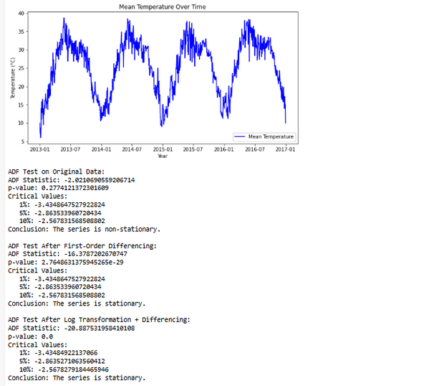

RESULT : Thus stationarity check has been implemented successfully using Augmented Dickey Fuller Test.

